1 : Labeled diagram of a typical home Wi-Fi setup

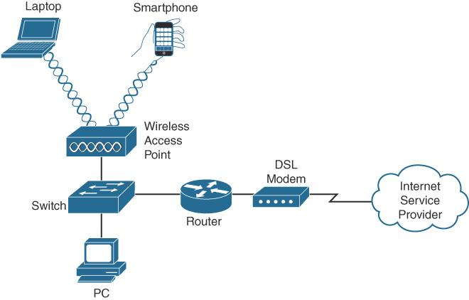

2 : Main functions and real-life examples of networking devices
Device | Main function | Real-life example
Modem | Connects the home network to the internet service provider (ISP). | A modem installed by an internet provider at home.
Router | Routes data between different networks and usually shares internet through Wi-Fi. | A Wi-Fi router used to connect family members' devices to the internet.
Switch | Connects multiple wired devices within the same local area network (LAN). | A switch connecting computers and printers in an office.
Access Point | Provides wireless network access to Wi-Fi devices. | An access point installed in a school to provide Wi-Fi in classrooms.
Network Cable | Carries data signals between network devices through a wired connection. | An Ethernet cable connecting a desktop computer to a router.

3 : Types of network cables with images and source links

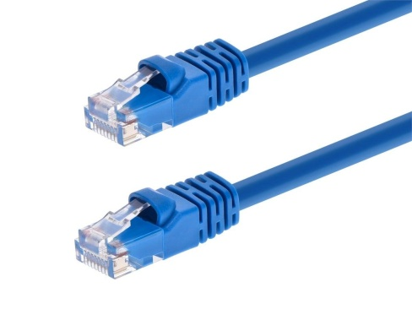
1. Ethernet cable (twisted-pair)
Used to connect computers, routers, switches, and other devices in a local area network (LAN).

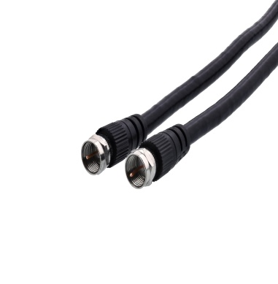
2. Coaxial cable
Commonly used for cable television, cable broadband internet, and some CCTV systems.

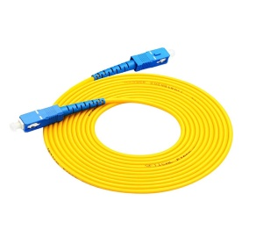
3. Fiber-optic cable
Used for high-speed internet, telecommunications, data centers, and long-distance data transmission.

4 : Comparison between router and switch

Feature | Router | Switch
Main use | Connects different networks. | Connects devices within the same LAN.
Typical location | Homes, offices, and network gateways. | Offices, computer labs, and server rooms.
How it handles data | Uses IP addresses to route packets between networks. | Usually uses MAC addresses to forward Ethernet frames within a LAN.
Internet connection | Usually connects the local network to the internet. | Does not normally provide internet routing by itself.
Wireless support | Many home routers include Wi-Fi. | Standard Ethernet switches generally use wired connections.
Example | A home Wi-Fi router sharing internet with a laptop and phone. | An office switch connecting several computers and printers.

